Molecular Biology

Lab 9

INTRODUCTION TO REAL-TIME PCR or QUANTITATIVE PCR (qPCR)

**Theory of Real-Time PCR**

Conventional or end-point PCR works well to detect the presence of the DNA that the primer pair

targets. Conventional PCR detects the amplified product (amplicon) by an **end-point**

**analysis — running the DNA on an agarose gel after the reactions are completed**. If the target DNA sequence is not there, no amplicon will appear on the agarose gel. If as little as a single DNA molecule that contains the target DNA sequence is in the sample, the amplification by 25-30 cycles is sufficient to generate detectable amplicons via electrophoresis. Thus, conventional PCR makes a highly sensitive assay for specific

DNA sequence, which is useful for the diagnosis of diseases, especially viral types. It is also a rapid, highly sensitive and specific assay for microbes in environmental samples. It is routinely used for differentiating genotypes in human samples. Results of such assays are often used in paternity testing and in crime scene analysis.

Through the use of **reverse transcriptase (an enzyme produced by retroviruses)**, conventional PCR has also become the standard for the detection of RNA targets, useful for analysis of gene expression in research and medical diagnosis. In this case, reverse transcriptase generates DNA from an RNA template, forming a template for the PCR polymerase amplification. This type of PCR is often called rt-PCR, but does not necessarily imply that real-time methods are used (see below.)

Real-time PCR is based on the same principles as conventional PCR. The reaction requires both forward and reverse primers bracketing the target region (amplicon),nucleotides, and a DNA polymerase such as *Taq*. However, real-time PCR allows the accumulation of amplified product to be detected and measured as the reaction progresses — in “real time”. The difference is the addition of a fluorescence chemistry, which enables product amplification to be monitored throughout the entire real-time reaction using specialized thermal cyclers equipped with fluorescence detection modules. The measured fluorescence reflects the amount of amplified product in each cycle. Real-time PCR results can either be qualitative (presence or absence of a sequence) or quantitative (number of copies of DNA).

Real-time PCR that is quantitative is also known as **qPCR**. The main advantage of using real-time PCR over conventional PCR is that real-time PCR allows you to determine the starting template copy number with accuracy and high sensitivity over a wide dynamic range. Conventional PCR can at best be semi-quantitative and the methods to obtain quantitative data can be quite complicated. One advantage of conventional PCR is better determination of the sizes of the amplified PCR products using conventional gel electrophoresis. Therefore, separating the real-time PCR products on a gel following amplification allows the visualization and determination of the size of the amplified products.

**How Real-Time PCR Works**

To best understand how real-time PCR works, think of what is happening in a PCR

reaction. During the first cycles of a PCR reaction, the amount of amplicon doubles.

The amount of amplicon after each cycle then multiplies exponentially in proportion to

the starting amount of template in the sample. At some point, this doubling slows as the

amount of substrate, nucleotides, and primers become used up. The DNA polymerase

also becomes less active after the prolonged heating within the thermal cycler. The loss

of doubling efficiency results in a plateau effect and the amount of amplicon produced

with the later thermal cycles is no longer proportional to the amount of template DNA in

the sample (Figure 1). After enough cycles, all amplicons reach a certain maximum

concentration, regardless of the initial concentration of template DNA.



**Figure 1. Amplification plot.** During the exponential phase, the amount of PCR product approximately doubles in each cycle. As the reaction proceeds and reaction components are consumed, the reaction slows and enters the plateau phase.

The key to determining the quantity of original template DNA present in a sample during

amplification is to examine the initial thermal cycles before reaching the plateau region of

amplification. To do this, the level of amplification is monitored continuously during the

thermal cycling. Initially, fluorescence remains at background levels, and increases in

fluorescence are not detectable (cycles 1–18 in Figure 1) even though PCR product

accumulates exponentially. Eventually, enough amplified product accumulates to yield

a detectable fluorescent signal. The cycle number at which this occurs is called the

threshold cycle, or CT. Since the CT value is measured in the exponential phase when

reagents are not limited, real-time qPCR can be used to reliably and accurately calculate

the initial amount of template present in the reaction.

The CT of a reaction is determined mainly by the amount of template present at the start

of the amplification reaction. If a large amount of template is present at the start of the

reaction, relatively few amplification cycles will be required to accumulate enough product to give a fluorescent signal above background. Thus, the reaction will have a low, or early, CT. In contrast, if a small amount of template is present at the start of the reaction, more amplification cycles will be required for the fluorescent signal to rise above background.

The most commonly used chemistries for real-time PCR are the DNA-binding dye

SYBR Green I and TaqMan hydrolysis probe. We provide an overview of SYBR Green I

fluorescence chemistry below.

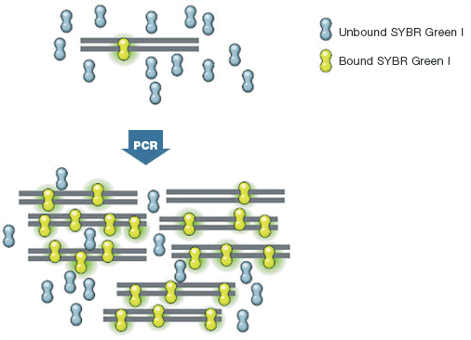

SYBR Green I is a DNA dye that binds non-discriminately to double-stranded DNA

(dsDNA). SYBR Green I exhibits minimal fluorescence when it is free in solution, but its

fluorescence increases dramatically (up to 1000-fold) upon binding to dsDNA (Figure 3).

As the PCR reaction progresses the amplified product accumulates exponentially, more

SYBR Green I binds, and fluorescence increases. The advantage of using SYBR Green I is its simplicity. This is similar to the action of ethidium bromide, but unlike ethidium

bromide, SYBR Green I does not interfere with DNA polymerases, so it can be added

directly to a PCR reaction mixture. SYBR Green I also has less background fluorescence than does ethidium bromide, is able to detect lower concentrations of double-stranded DNA, and is not hazardous.

**Optimizing a Real-Time Quantitative PCR Assay (qPCR)**

Since real-time quantitation is based on the relationship between initial template amount

and the CT value obtained during amplification, an optimal qPCR assay is absolutely

essential for accurate and reproducible quantitation of your particular sample. The

hallmarks of an optimized qPCR assay are:

• Linear standard curve

• Consistency across replicate reactions

A powerful way to determine whether your qPCR assay is optimized is to run a set of

serial dilutions of template DNA and use the results to generate a standard curve. The

template used for this purpose can be a target with known concentration (for example,

nanograms of genomic DNA or copies of plasmid DNA) or a sample of unknown quantity

(for example, cDNA). A standard curve is constructed by plotting the log of the starting

quantity of template (or the dilution factor, for unknown quantities) against the CT value

obtained during amplification of each dilution. The equation of the linear regression line,

along with Pearson’s correlation coefficient (r) or the coefficient of determination (R2), can then be used to evaluate whether your qPCR assay is optimized. Ideally, the dilution series will produce amplification curves that are evenly spaced, as shown in Figure 2A. If perfect doubling occurs with each amplification cycle, the spacing of the fluorescence curves will be determined by the equation 2n = dilution factor, where

n is the number of cycles between curves at the fluorescence threshold (in other words,

the difference between the CT values of the curves). For example, with a 10-fold serial

dilution of DNA, 2n = 10. Therefore, n = 3.32, and the CT values should be separated

by 3.32 cycles. Evenly spaced amplification curves will produce linear standard curves,

as shown in Figure 2B. The equation and r values of the linear regression lines are

shown above the plot.

Figure 2A.

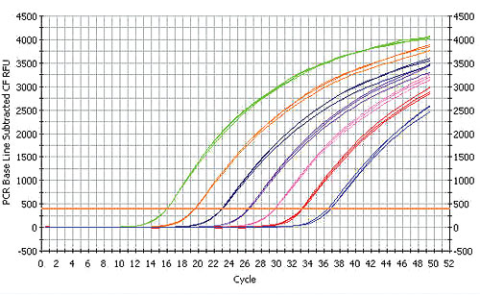

**Figure 2. Generating a standard curve to assess reaction optimization.** A standard curve was generated using a 10-fold dilution of a template amplified on the iCycler iQ® real-time system. Each dilution was assayed in triplicate.

1. Amplification curves of the dilution series. **B.** Standard curve with the CT plotted against the log of the starting quantity of template for each dilution. 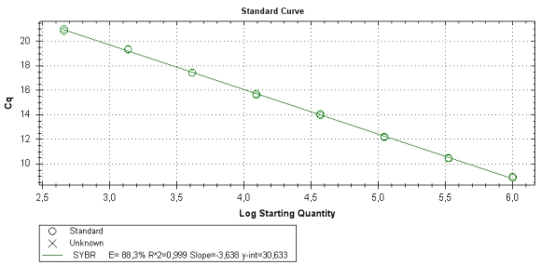

**Procedure**

In today’s lab we will use qPCR to amplify a portion of the GFP gene. As you are well aware, the target sequence from the gene has been cloned into the pGLO plasmid. We will prepare dilutions of the target sequence to test the optimization of the qPCR, and we will choose 1 or 2 of the primer pairs that worked well in our endpoint PCR experiment 2 weeks ago.

Today’s experiment will utilize serial dilutions of the same template to illustrate the quantitative application of real-time (qPCR). In the background reading you were asked to “imagine” what actually occurs during PCR, especially in the first rounds of cycling.

Each sample will begin amplifying the available template exponentially. The more starting template, the quicker the amplified product accumulates. qPCR gives us the ability to monitor this accumulation as it occurs, not just look at the final accumulated product as with conventional PCR. Accumulation is noted as a change in fluorescence. Samples with more template reach the threshold for fluorescence detection sooner (at an earlier cycle) than samples with less template. We call this threshold cycle the CT value for the experiment.

**Objectives:**

1. Understand the theory of qPCR

2. Understand the use of standards in optimizing qPCR

3. Prepare serial dilutions

4. Interpret the qPCR results after a run.

**Materials**

* pGLO plasmid (template)
* water
* 2X Sybr Green PCR Supermix (contains taq polymerase, dNTPs, Sybr green).
* Primer pair that worked well in end-point PCR. (10 M stock)
* qPCR tubes/plate

**Protocol—Break into 3 groups for todays lab—you must pipet carefully, mix carefully, plan ahead….**

**Make dilutions of template**

1. Obtain a tube of the pGLO DNA (note its concentration)

2. Label 7 microfuge tubes with the following information

1. 100 (undiluted—pGLO plasmid)

2. 10-1

3. 10-2

4. 10-3

5. 10-4

6. 10-5

7. NT (no template)

3. Pipette 45 l of fresh molecular grade water into each of the dilution tubes (2-7). Make your first 1/10 dilution by transferring 5 l of the DNA solution into tube 2. Mix by gentle pipetting.

4. Change tips and make the next dilution by transferring 5 l of the well-mixed DNA solution from tube 2 into tube 3. Mix well by gentle pipetting.

5. Repeat to make 10-fold *serial* dilutions in tubes, 4, 5, and 6. Add no DNA to tube 7.

6. Place dilutions on ice.

**Prepare Sybr Green master mix as follows.**

1. For each diluted sample (2-7) make 80 l of mastermix in a separate labeled tube
   1. 50 l Sybr Green supermix
   2. 2 l forward primer
   3. 2 l reverse primer
   4. 26 l water

**Combining template and mastermix**

1. Add 20 l of each diluted pGLO sample to each tube of master mix. Mix well. Spin down.

2. Aliquot 25 l of the contents of each tube into separate wells of your plate strip (these are triplicates so they go side by side in each row).

Try NOT to introduce bubbles or air space when loading your triplicates.  place on ice after finished.

10. Run the qPCR experiment in Dr. Supers thermal cycler. (see set up in 216)

11. Results will be discussed next week.